1. Install Visual Studio Code

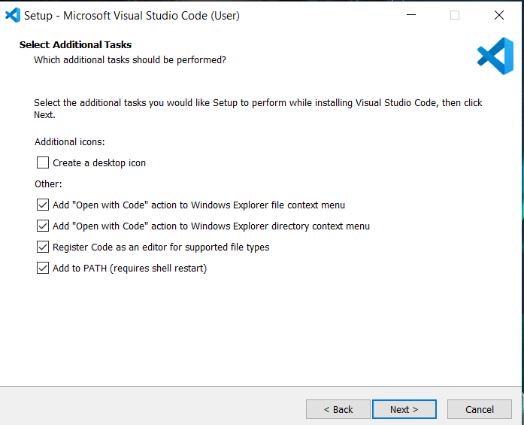

1. Download Python 3.8.* and add Python to the PATH option

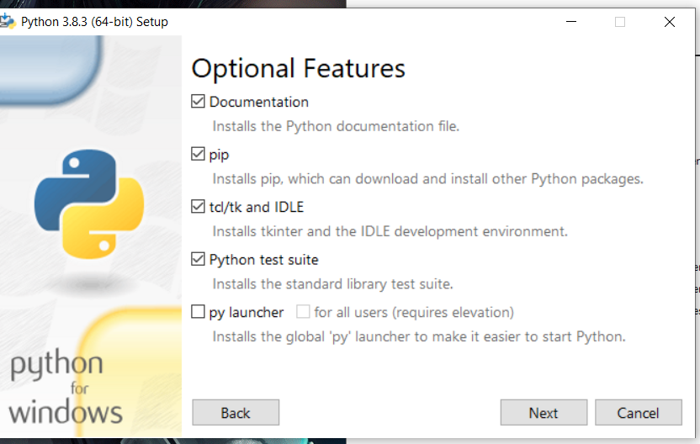

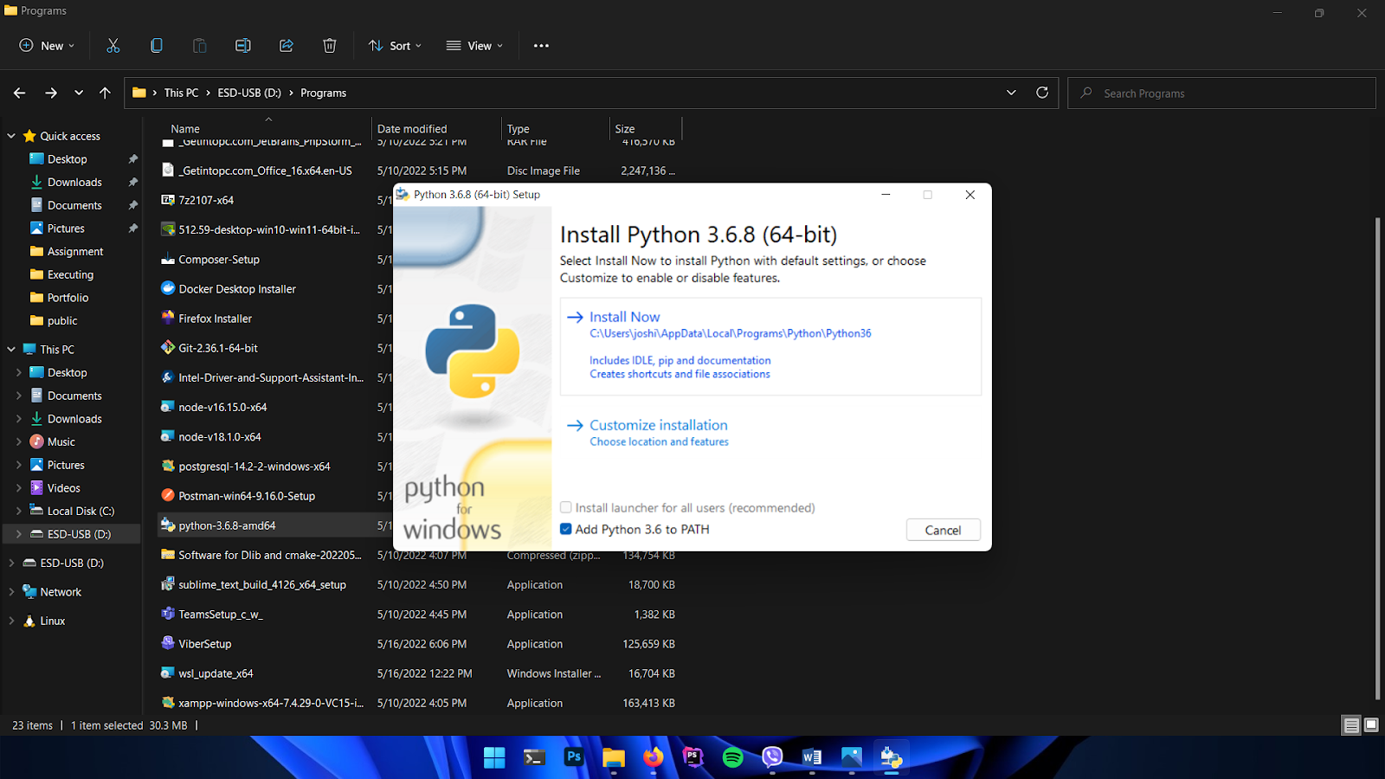

1. Open Command Prompt in the computer and type the following commands one by one. (Make sure python is properly installed in your System).
   1. Pip install pandas
   2. Pip install matplotlib
   3. Pip install keras == 2.8.0
   4. Pip install tensorflow == 2.8.0
   5. Pip install opencv
   6. Pip install sklearn
   7. Pip install seaborn
   8. Pip install numpy
2. After installing the packages , Open the Visual Studio Code.
3. Go to the Extension Section in left top corner and install the following extensions.
   1. Jupyter
   2. Jupyter Notebook
   3. Python
   4. Anaconda
   5. Jupyter Keymap
   6. NodeJS

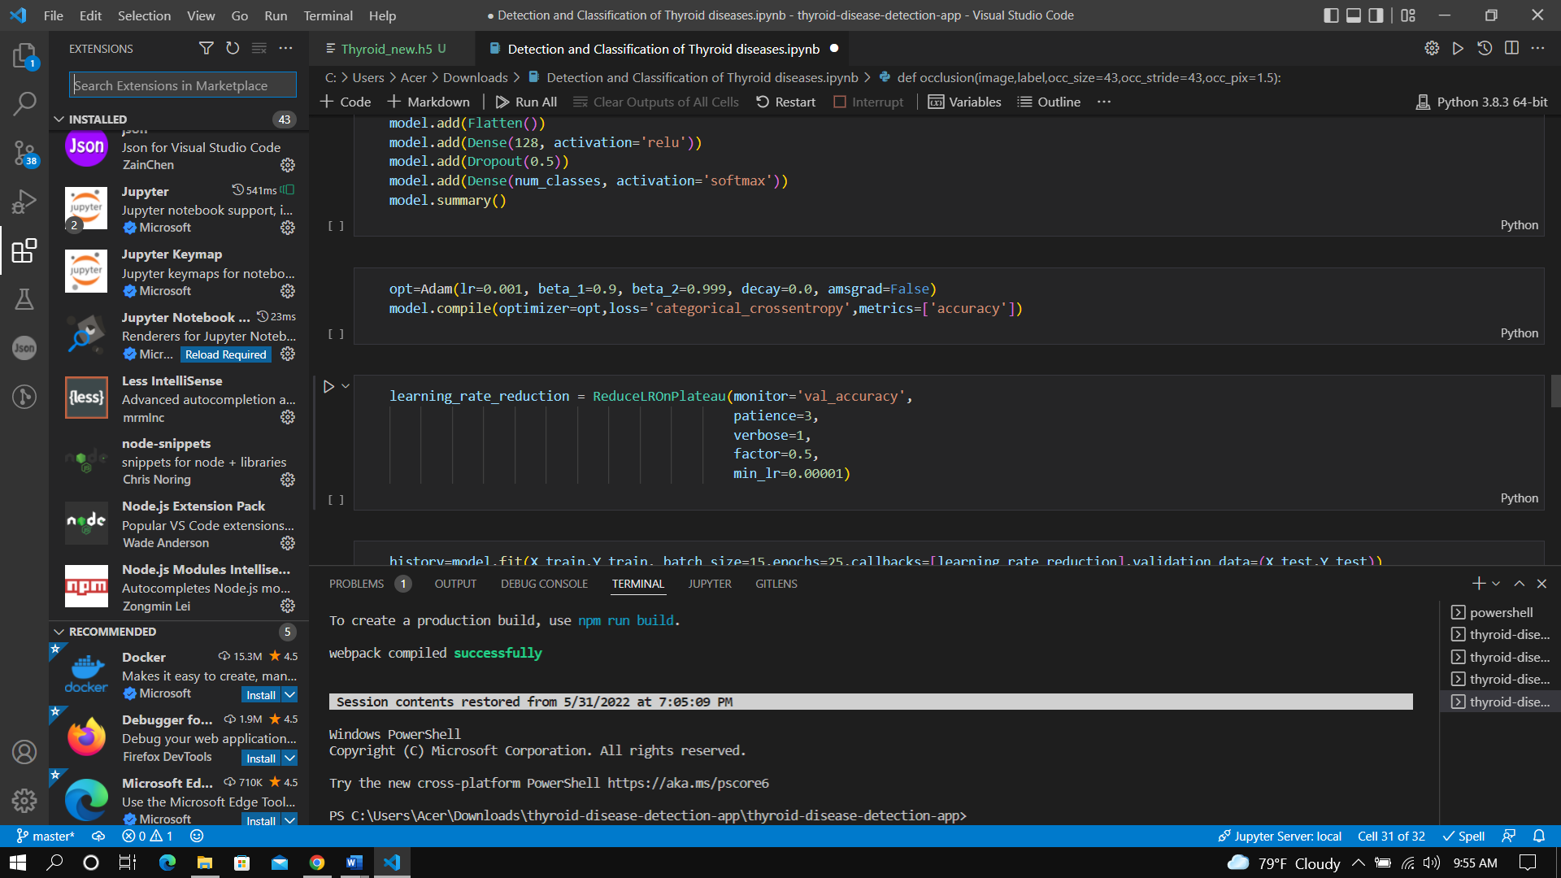

1. Open the “Source Code” from the File Menu

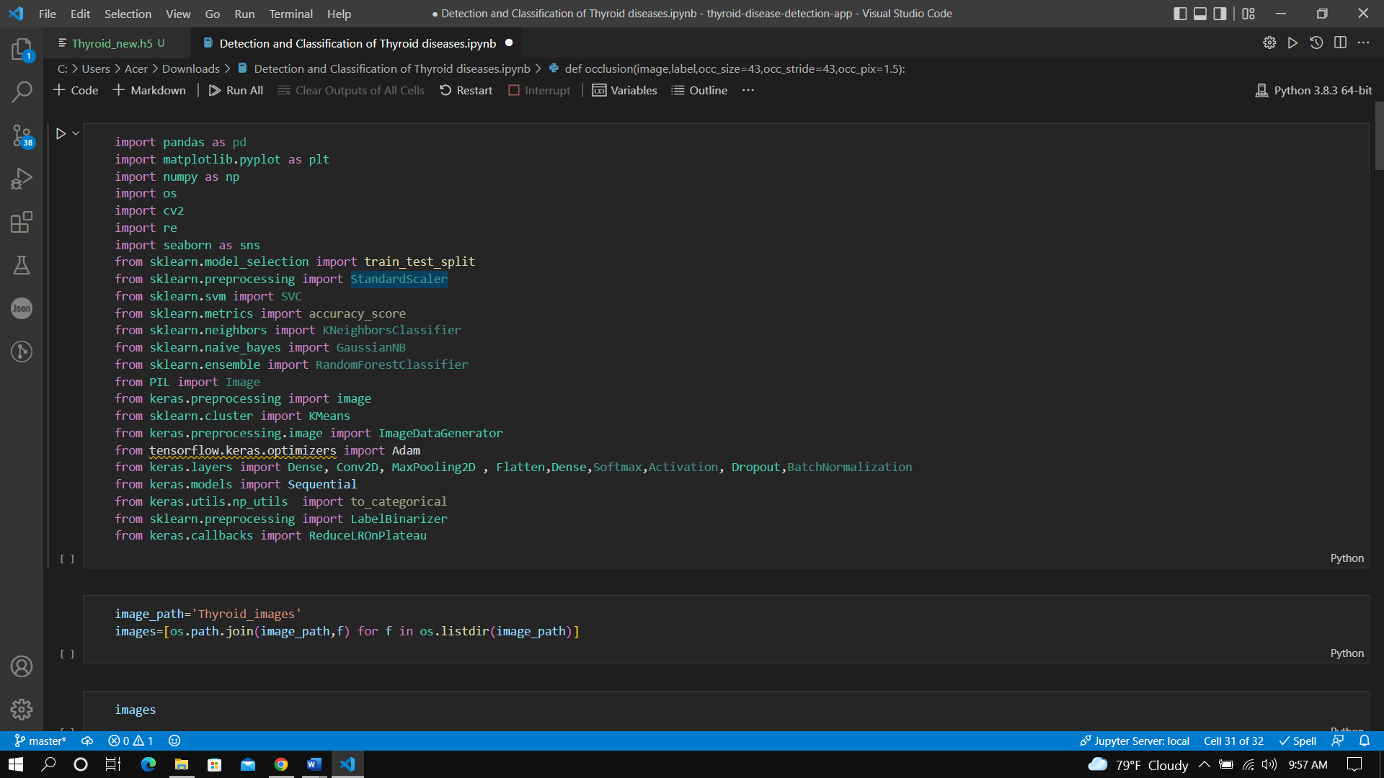

1. Press on Run All option , it takes about an hour.

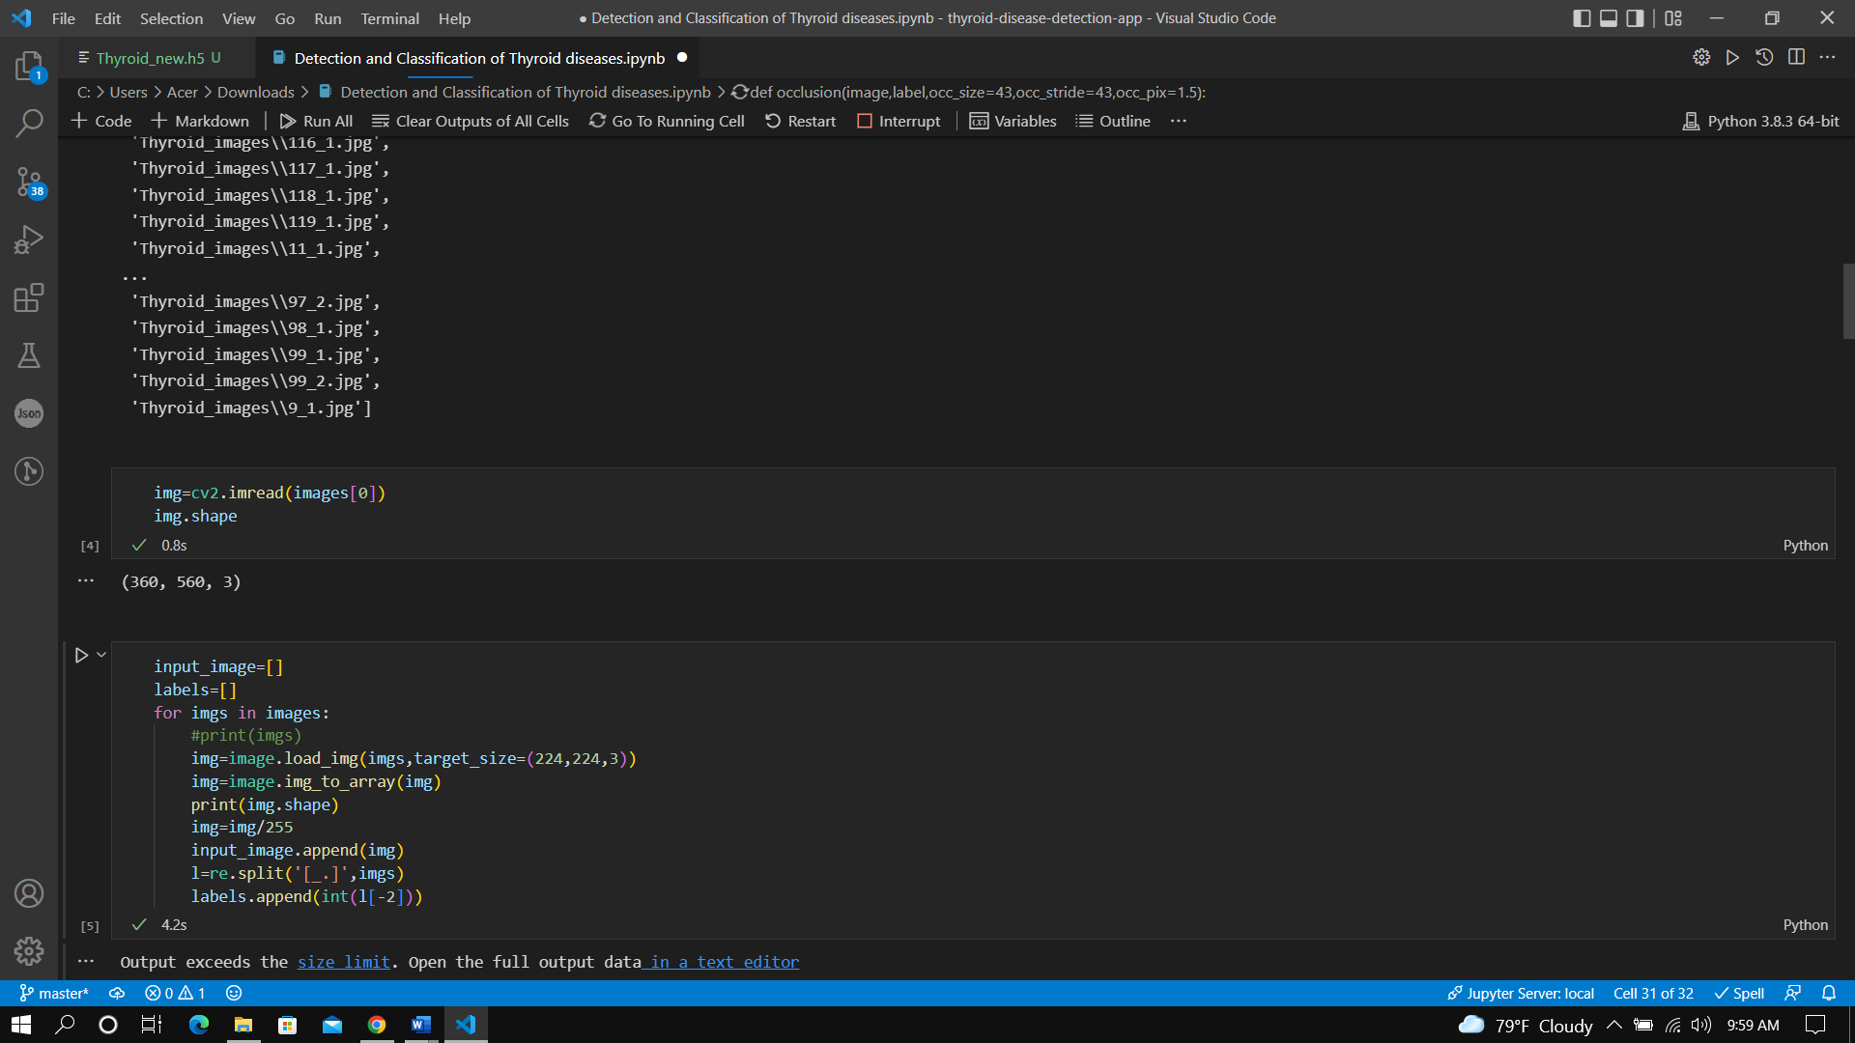

1. It creates the Model named as “Thyroid_new.h5”



1. At the end of Code You will see Images . Some of them are highlighted with red square box which had detected Thyroid

This method scans Lots of Ultrasound Images at once.

1. Extract the folder named as “ thyroid-detection-diseases-app” and open the folder in Visual Studio Code.

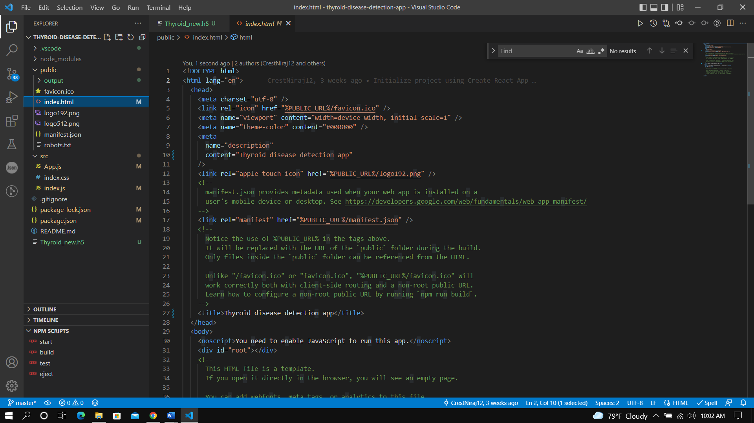

1. Press “Ctrl + ‘ “ . This opens an Terminal Section. Type npm start” and press enter

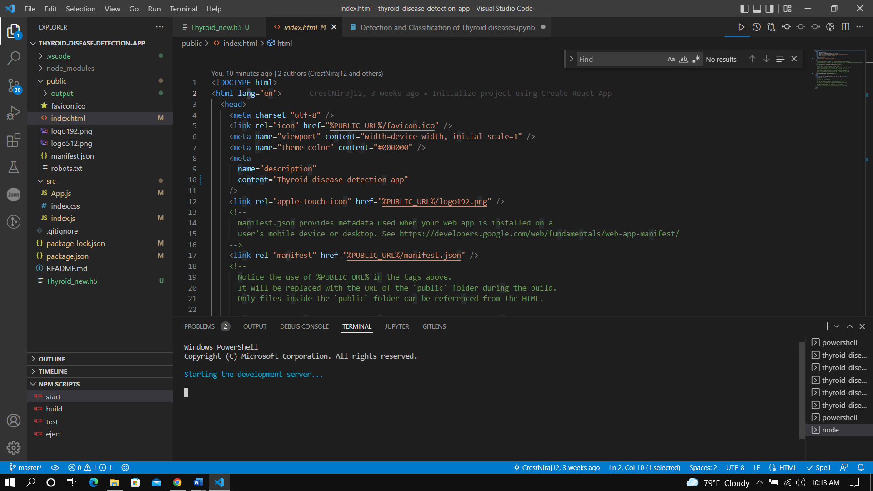

1. This will open an browser and following page will be open

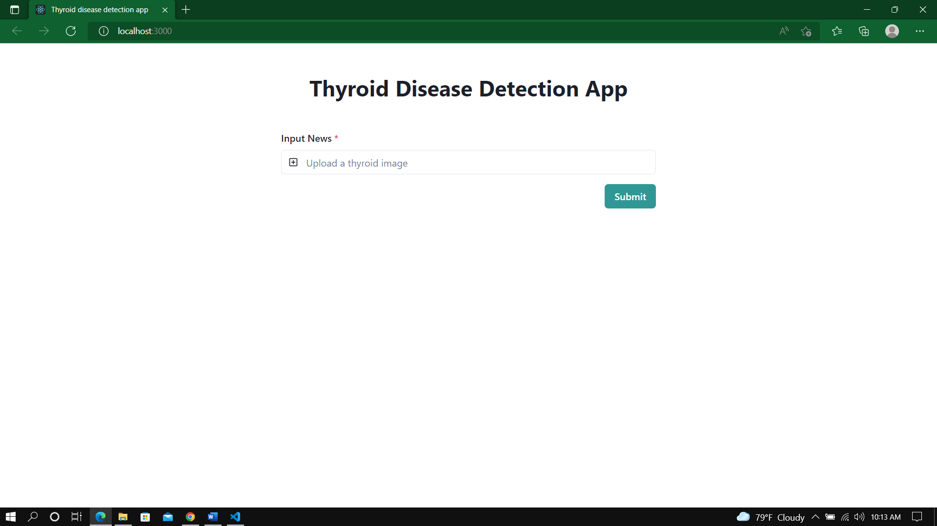

1. This is used to detect thyroid for a single Ultrasound Image.
2. Upload an image and press Submit

